Operations/Work/Job Activity covered by this assessment: Polishing Machine
Required Personal Protective Equipment (PPE) :

Safety glasses must be worn at times. |   Long and loose hair must be contained.
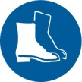  Appropriate footwear with substantial uppers must be worn. |   Close fitting/protective clothing to cover arms and legs must be worn.
Respiratory protection devices required. |   Oil free leather gloves and spats must be worn.

Hearing protection must be used when using this machine.

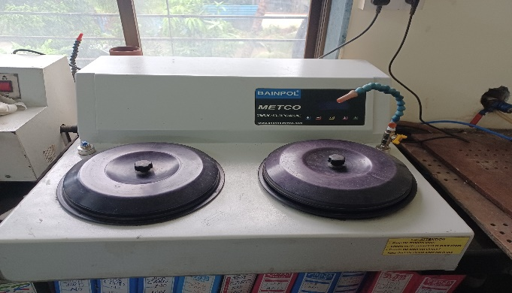
- Keep a set of 80, 120, 180, 220, 320, 400, 600, 800, 1000, 1500 and 2500 grit emery paper ready for polishing

- Keep one emery paper of Grit 120 on one wheel and Grit 180 on the other wheel.
Fig 1
- Switch on the polishing machine and set the RPM of the motor to desired speed.

- Wear Gloves on your hand before polishing.

- Spray little water on the Emery of Grit 120 and press the mounted specimen with a little pressure and move it in the opposite direction to the wheel rotation.
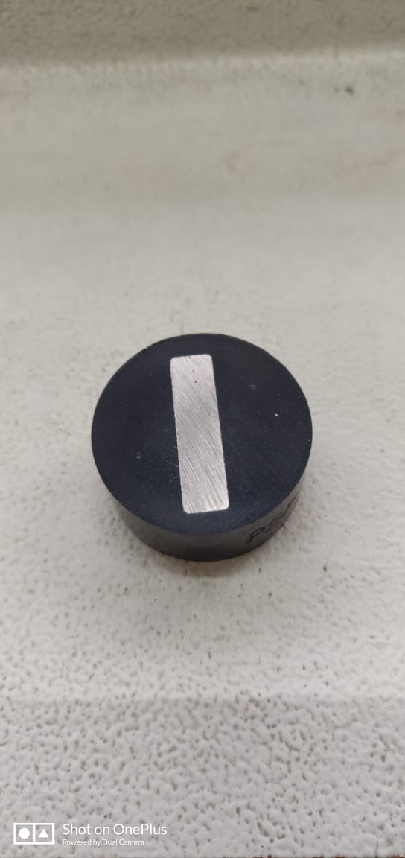
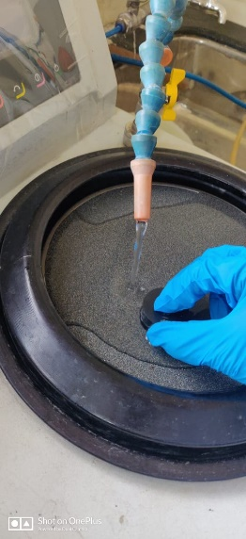
- Ensure that long axis of your specimen is perpendicular to the direction of rotation of the wheel as shown in Fig 2

Fig 2

- After 20-30 seconds, change the specimen so that its long axis is parallel to the rotation of the wheel. This is done by rotating the specimen 90 degrees to the earlier direction.

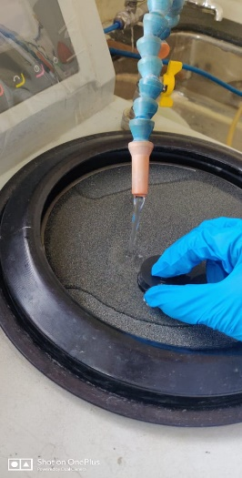
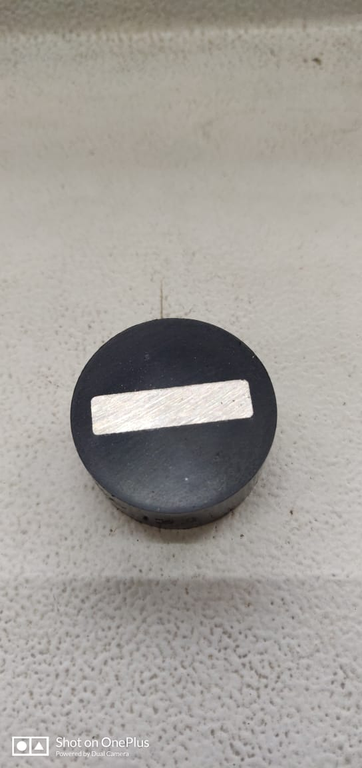
Fig 3

- Ensure to cool the specimen by dipping it in water at regular intervals

- Repeat Process detailed in 6 and 7 till the polished lines are parallel and uniform over the entire surface by observing visually the polished surface at frequent intervals.

- Repeat processes from S.No.3 to S.No.8 for all emery paper Grit upto 2500.

- After the final polishing and cleaning the surface of the mounted specimen with detergent, dry the specimen completely.

- Identify the coated surface on the polished sample and place it accordingly on the stage of the microscope and focus it with 10X objective.
reaches 160⁰ C. Maintain the pressure.

